COSC175 Homework #1 (HW1)

Assignment Name: HW1: (SDLC & IPO)
Due date: 9/29/2022, by 11:00 am.
Grade for assignment: 25 points
Purpose: Understand the Software Development Life Cycle (SDLC), and how to achieve step 1 of the SDLC through the use of the Input Process Output (IPO) analysis tool. Assignment accomplishes course learning objective “Understand and apply the software development process.” Assignment also provides preparation for COSC236 course, and enhances skills needed in Information Technology (IT) and Computer Science industries.
Skills: Purpose of assignment is to help you practice the following skills.
-Achieve step 1 (Analysis) of the SDLC
-Utilize IPO analysis tool
Knowledge: Become familiar with how to define the problem that needs to be solved, before writing the computer code.
****************************************************************************
Place your Name(s) below:
Pairs work: Please work in pairs. One student in team should submit work. Put your first and last name on the assignment and your partner’s first and last name on the assignment
Partner 1: Name Blessing Abumere

Partner 2: Name _______________________________

Please note if one partner did not work on all problems:

Submission instructions: All submissions will be done using blackboard. Answers are to be submitted in a Microsoft word document.

Task:
Examples: Refer to your notes from class, the Introduction PowerPoint, Lab 1 Security Injection on SDLC, in class exercises and any available videos. (All located in Blackboard).

Part1: (13 points)
- Describe the SDLC:
  - Include a chart using Smart Art or some other chart tool
  - Include a description of each step in detail
  - Include security!
  - Indicate (highlight on the chart) what step is being used when we use IPOs(Red)
  - SUBMIT your Chart (Below):
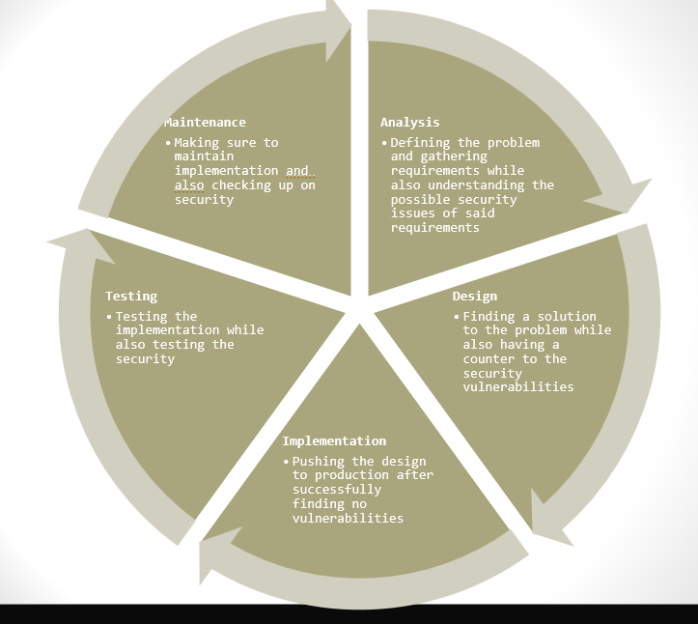

Part2: (12 points)
Defining the Problem: For each of the following, define the problem by specifying the input and output (use good variable names as described in class); and processing steps.

(Note: The processing steps should be very general, for example: Calculate tax, Display sum, etc. Remember we are doing phase 1 (analysis) only – Defining the Problem.)

- A program is required which will receive two numbers, calculate them, and display to the screen their sum, difference, product, and quotient.
Input | Processing | Output
Num1 | Read Num1, Num2 | sum
Num2 | Calculate sum, difference, product, quotient | difference
 | Display sum, difference, product , quotient | product
 |  | quotient

- Write a program to input three test scores and calculate the average. Print the average.

Input | Processing | Output
score1 | Read score1, score2, score3 | average
score2 | Calculate average
score3 | Display average

*****************************************************************************
Criteria for Success:
a) Be sure to complete of the Security Injection in Lab 1 (part 3) on SDLC; this will help you to complete Part 1 above.
b) Late policy: Late submissions will receive a zero grade. Get help during the week so that you can submit on time.

